How to use ModBusTestSoft to Test
This software is downloaded from the network, do not use for commercial purposes. For testing purposes only.
If you want to buy a genuine copy, please contact WinTech SoftWare to buy.

Step 1: Click ModBusTestSoft path and double click ModScan32.exe.
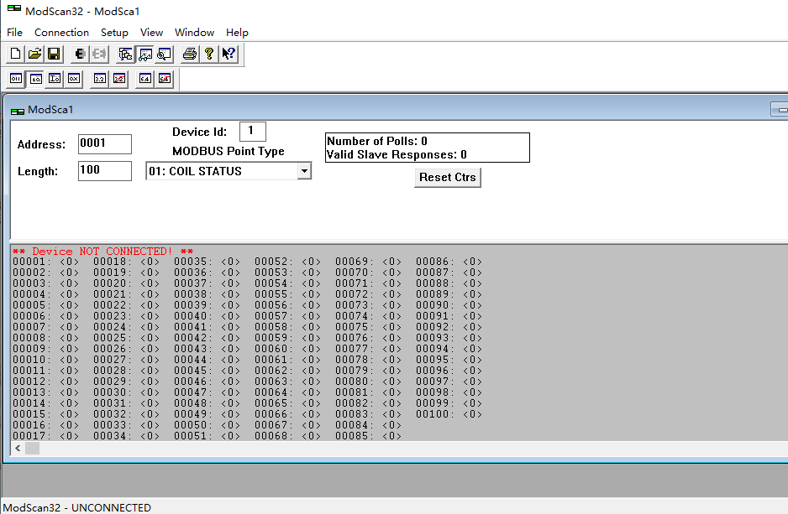
Click top bar Connection.
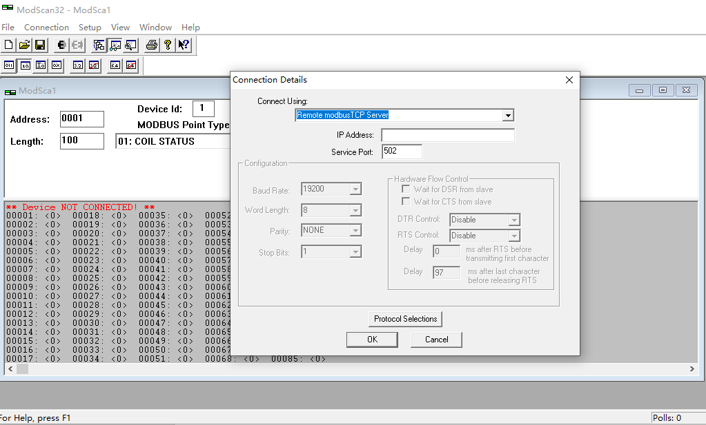
If you want to use ModBus TCP，please select Remote ModbusTCP Server
IP Address is reader IP, Server Port is reader local port.
If you use ModBus RS232 or RS485, Select Direct Connection to COM, choose correct COM port.
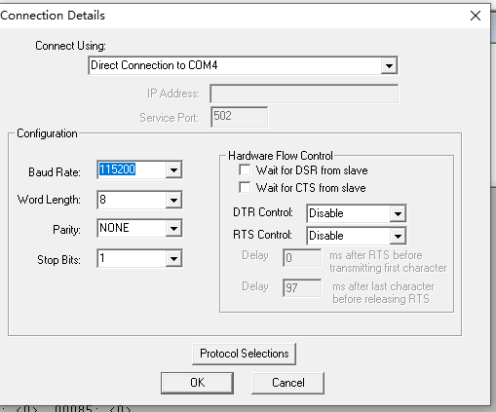
Baud Rate is reader baudrate, Parity select NONE.
Then click OK
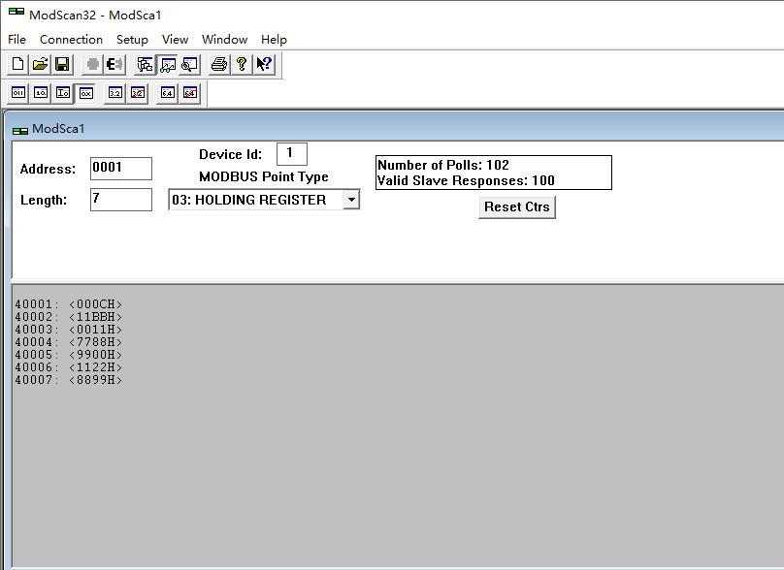
In the main interface ,it need set DeviceID and Length and ModBus Point Type.
DeviceID is Reader 485 address.
Length must set 7, ModBus Point Type can choose 03 or 04.
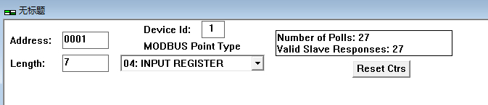
After set these parameters you can get data.
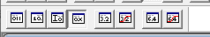
Select 0X mean Hex show.
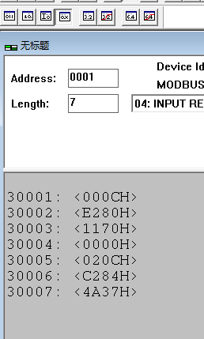
As the picture show, it have 7 registers value, every register value is 16 binarys.
30001： it mean tagID length, example: 000CH mean tagID length is 12 bytes.
If show 0000H mean no tag read.
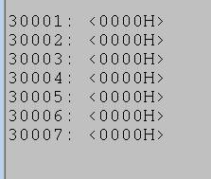 As the picture show, reader not read tag now.
30002 – 30007 : mean tagID data.
this mean tagID is E28011700000020CC2844A37
if you use PLC to connect reader, the PLC should first get 30001 register to check whether is tag exist, then get data.

